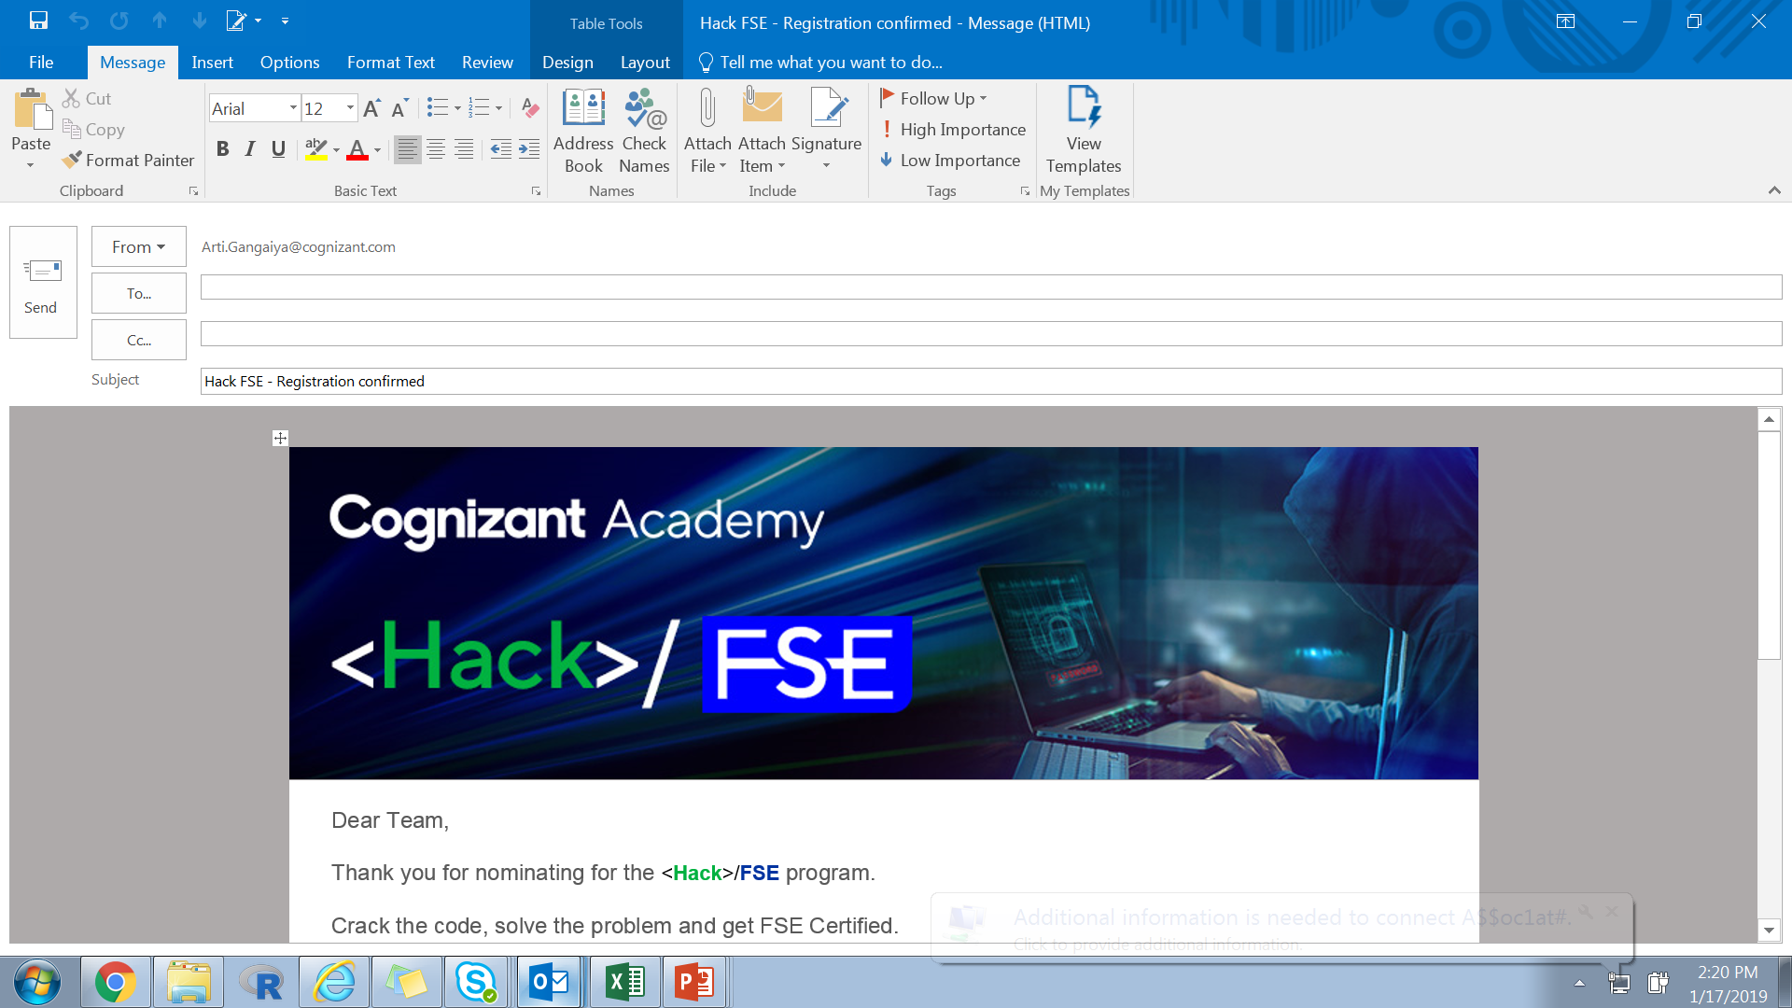

Outreach Feedback System Management

By:

Priya Raju (743698)

Table of Contents

1.0 Introduction 3

1.1 Purpose 3

1.2 Scope 3

1.3 Technology Used to Develop the Project 3

1.4 Project Design 3

1.5 Future Enhancement of the Project 4

# Introduction

This system will request feedback/ survey response from Associates based on the Outreach volunteering activity they opted to particiapte. Also the system processed the feedback and shows various statistics to the Admins, PMOs and POCs.

## Purpose

This section should:

This document is meant for the evaluators of the working model build

It gives a high level idea as to how the system works.

## Scope

This system :

1. Captures the feedback/ survey submitted by various associates. Also helps the Admin team to trigger various reports based on the input submitted by associates
2. The basic goal of this system is to help the Outreach team gather feedback from associates based on the volunteering activity and also will help them improve the activities based on the feedback recieved.
3. The system is intended to be used by Cognizant associates designated as Admins, PMOs and POCs

## Technology Usedto Develop the Project:

**Technologies and Softwares used:**

1. React JS for the reponsive front end (Visual Studio Code as text editor)
2. SpringBoot for the backend (Spring Tool Suit)
3. My SQL for the Database
4. Jenkins , Git for CI/CD
5. Dcker for containerizing the application
6. Tried to use Microsoft Azure for cloud deployment.
7. Jmeter for testing the load handling capabilities

## Project Design

Basic flow:

Admin Flow

## When admin logs in, he can see the dashboard. It has the following features.

1. View avg feedback ratings provided by associates by month. It is available in the form of graphs.

2. Feedback Meter- This provides at a glimpse the number of feedback that is pending for each event and the POC of the concerned event.

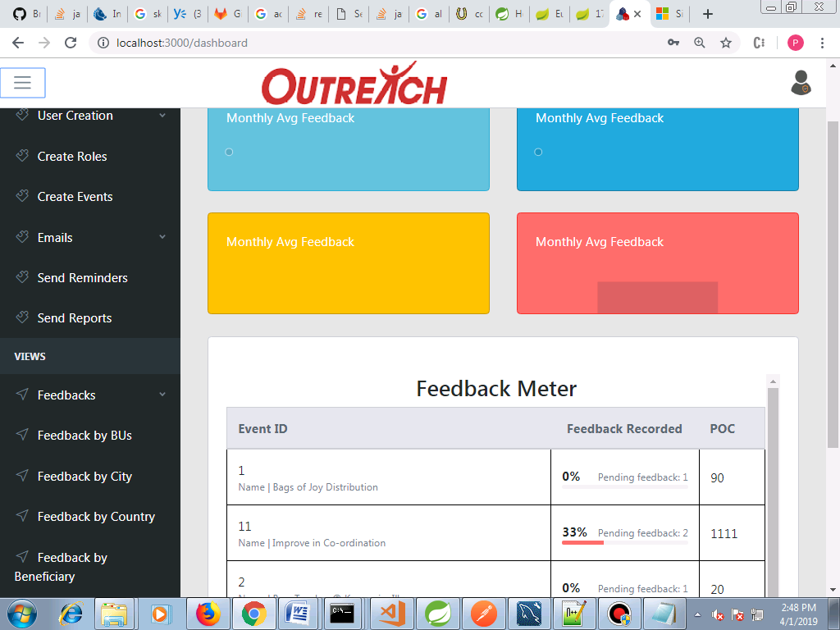

**Create Roles**

1. Create roles by providing basic details

2. Option to create number of roles using excel upload.(The file must reside that the specified path)

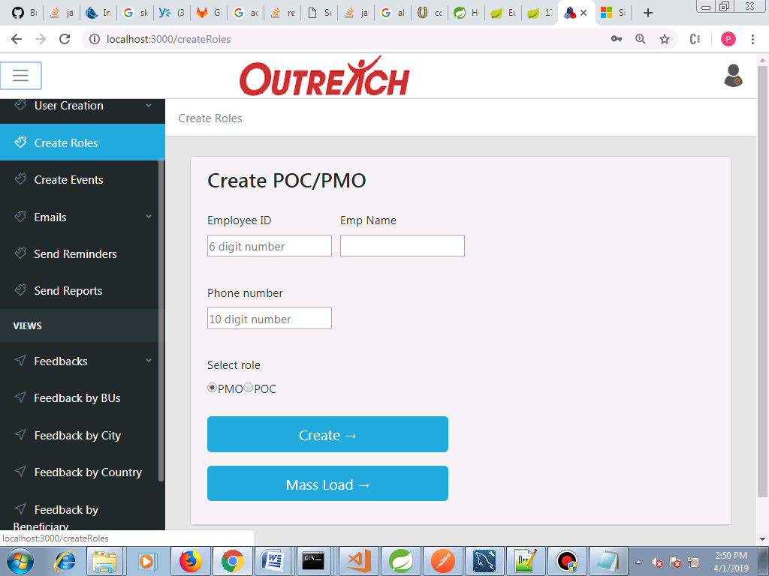

Create Events

1. Create a new outreach event

2.Option to create number of events using excel upload(The file must reside at the specified path)

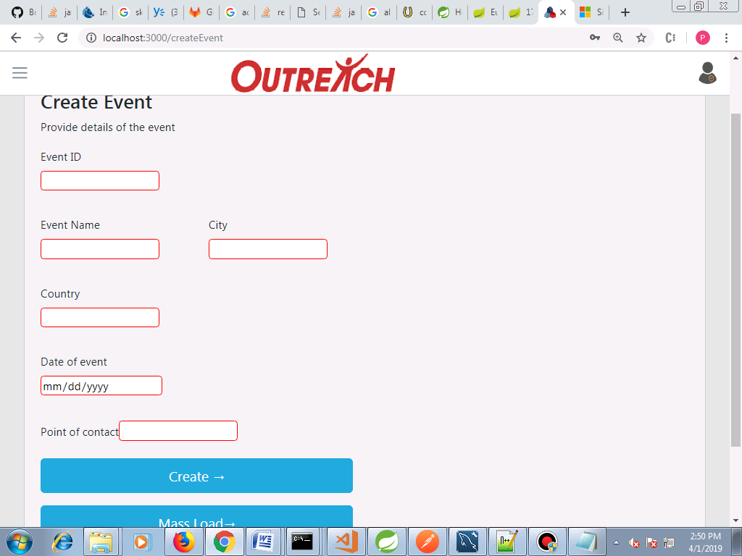

Send reminder mails

This mail will be triggered for those associates who didnt give feedback. The content can be modified.

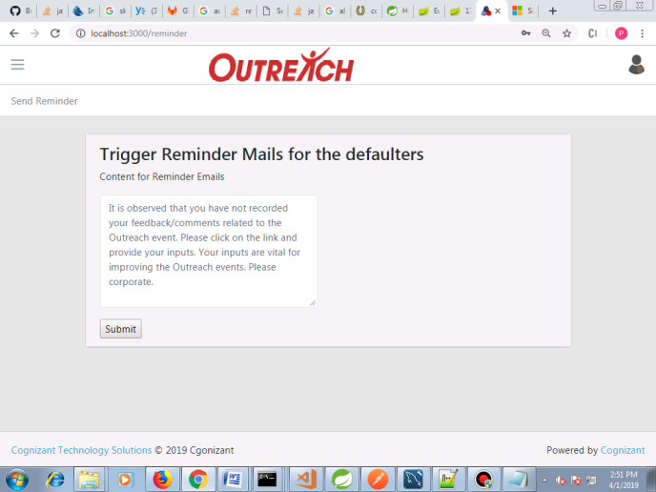

Send acknowledgement for those who gave feedback.

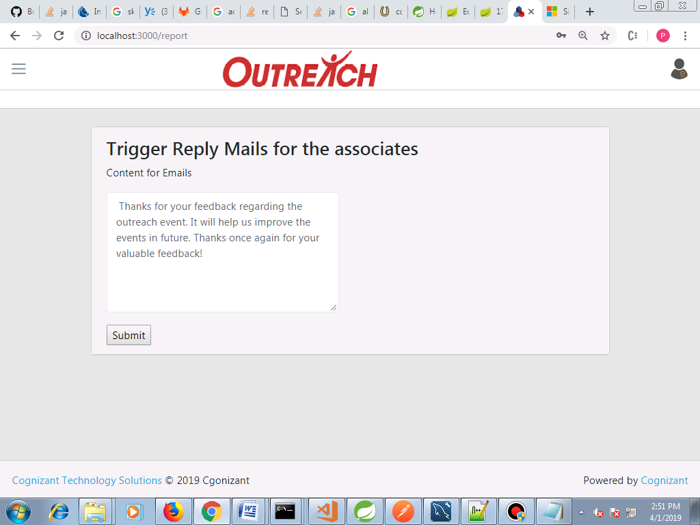

View feedback statistics.

Feedback by BU

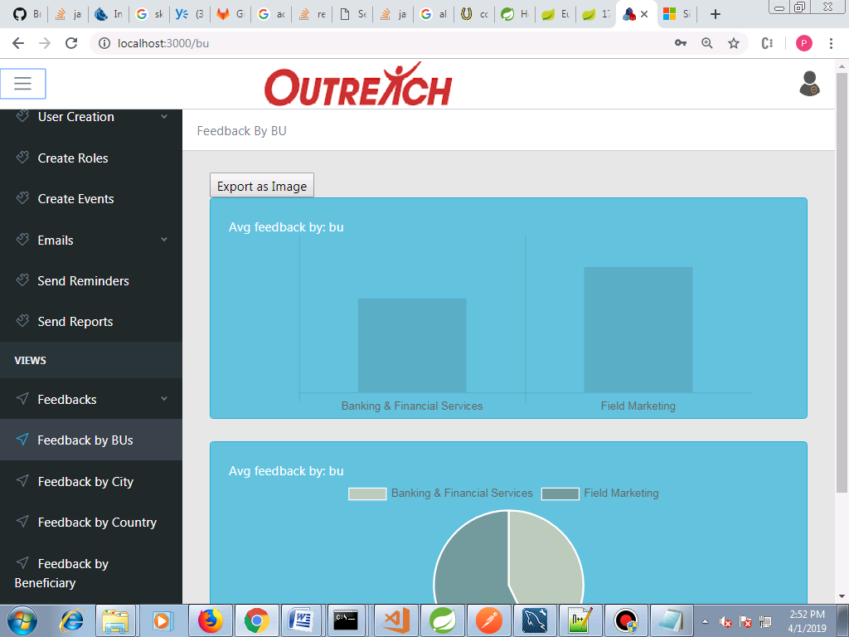

Feedback by City

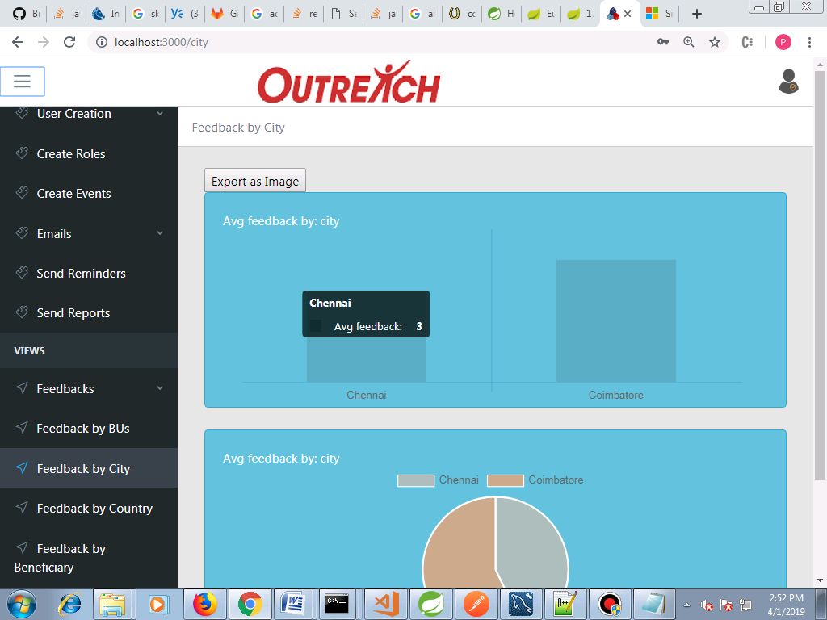

Feedback by Country

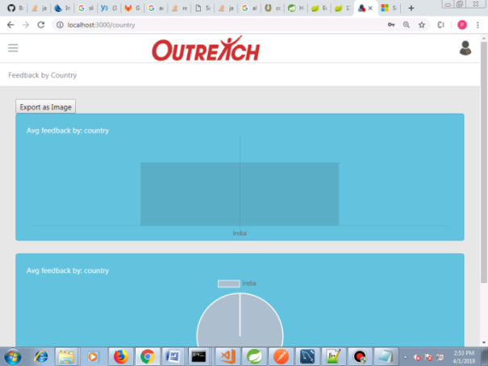

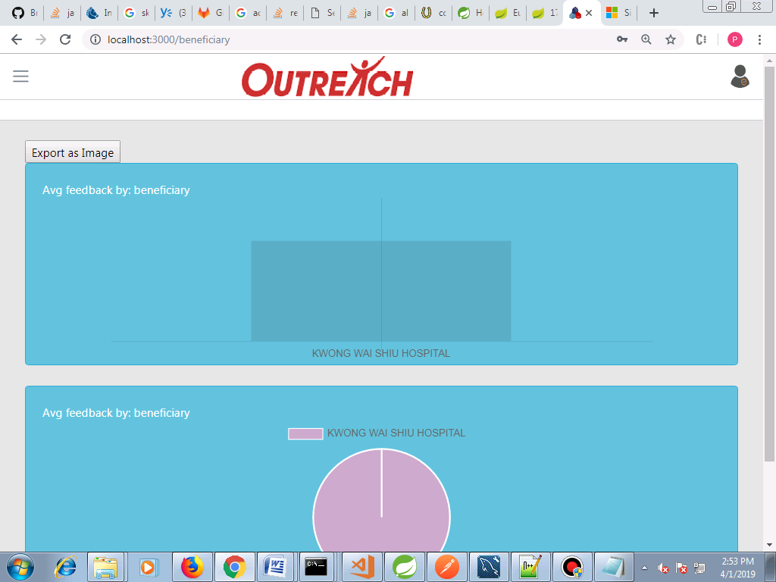

**Feedback by Beneficiary**

**Download Feedback Report**

Can view the ratings provided by each emp for the events . Also has the option to download the report as excel.

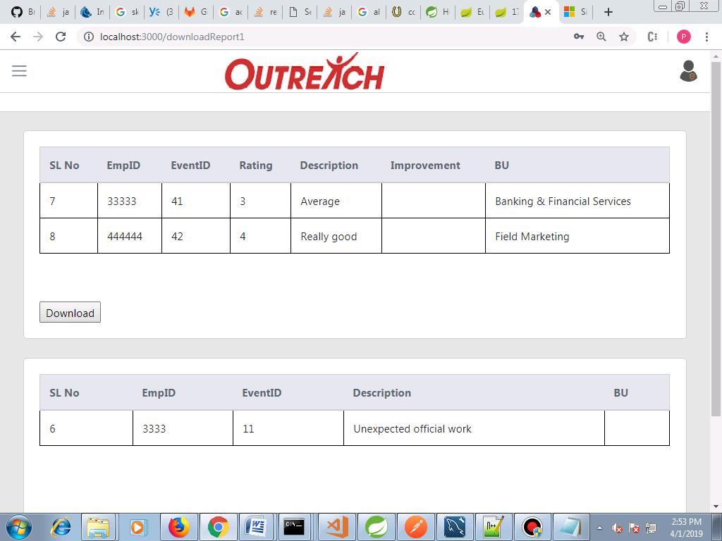

Login as PMO

PMO can view the average feedback rating given by associates.

Login as POC

POC can view the avg rating of his respective event.

Note- Whent he Admin creates a POC/PMO, the default user name is his empID and pwd is <empid>@cts.

It can be reset lateron by the user.

**Feedback forms**

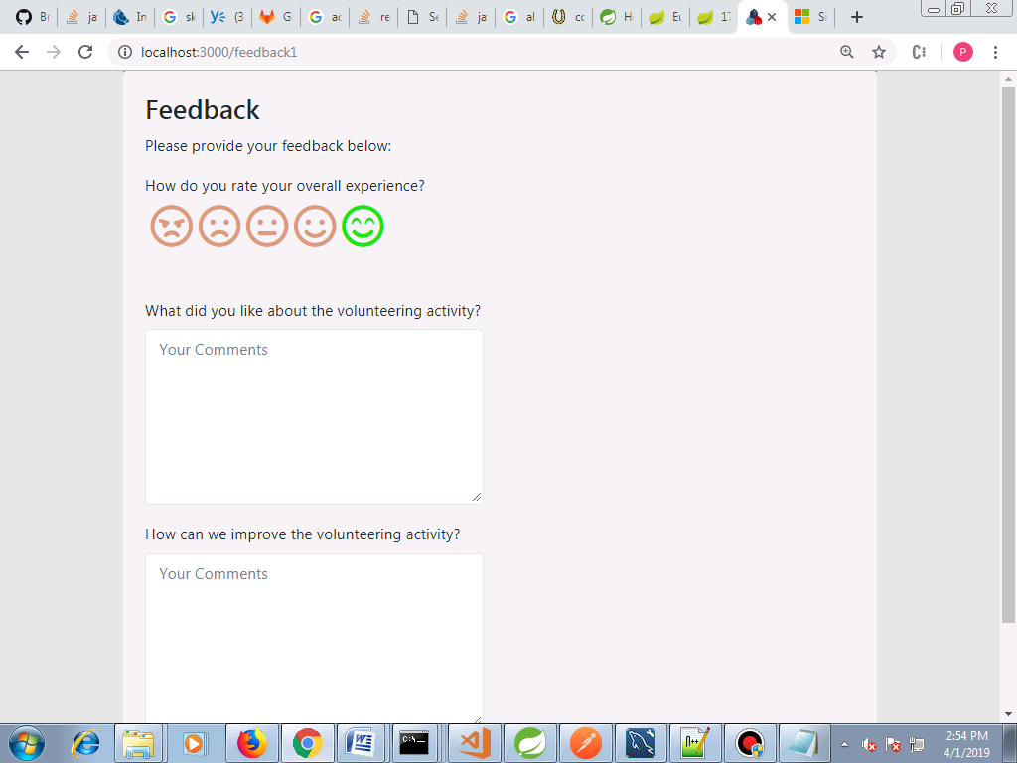

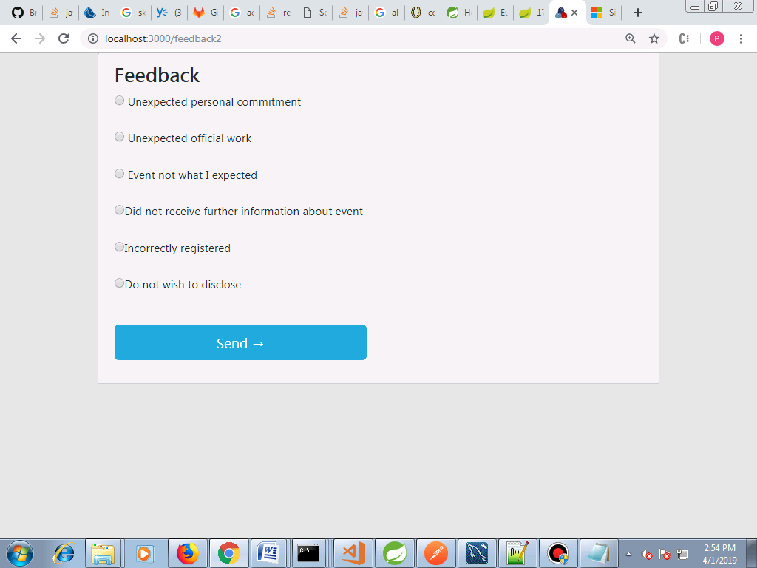

## Future Enhancement of the Project

Admin can triggered user creation mails when the user is created, thus informing him the credentials to be used.

When an event is created, the concerned POC can be intimated by email.

Option to send the reports to the PMOs and POCs from the application itself. (At present the admins can dowload the reports and has to send emails manually)